12.1.1

Problem Statement
Write a Python program to manage a phone number database using a dictionary. The dictionary stores contact names as keys and phone numbers as values.

Algorithm
- Start
- Create empty dictionary
- Read number of operations
- For each operation:
If ADD → insert contact
If REMOVE → delete contact
If DISPLAY → print all contacts (sorted) or "No contacts"
- Stop

Flowchart :
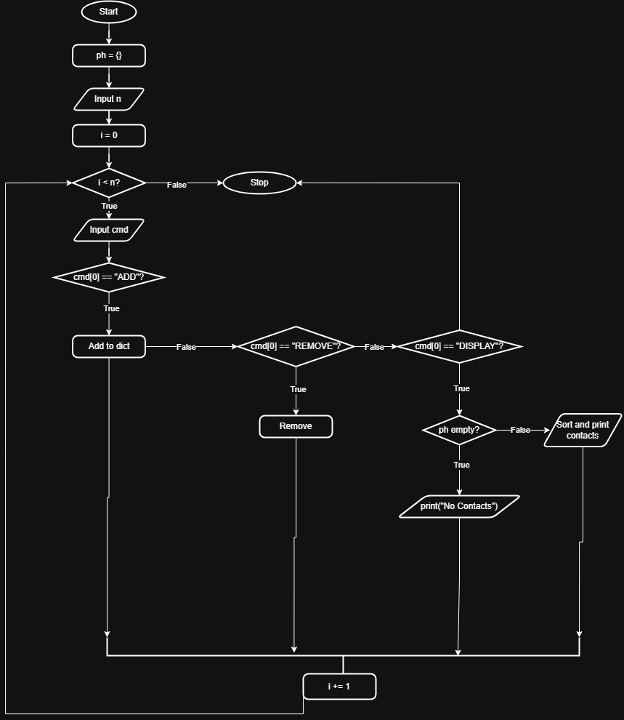

Execution:
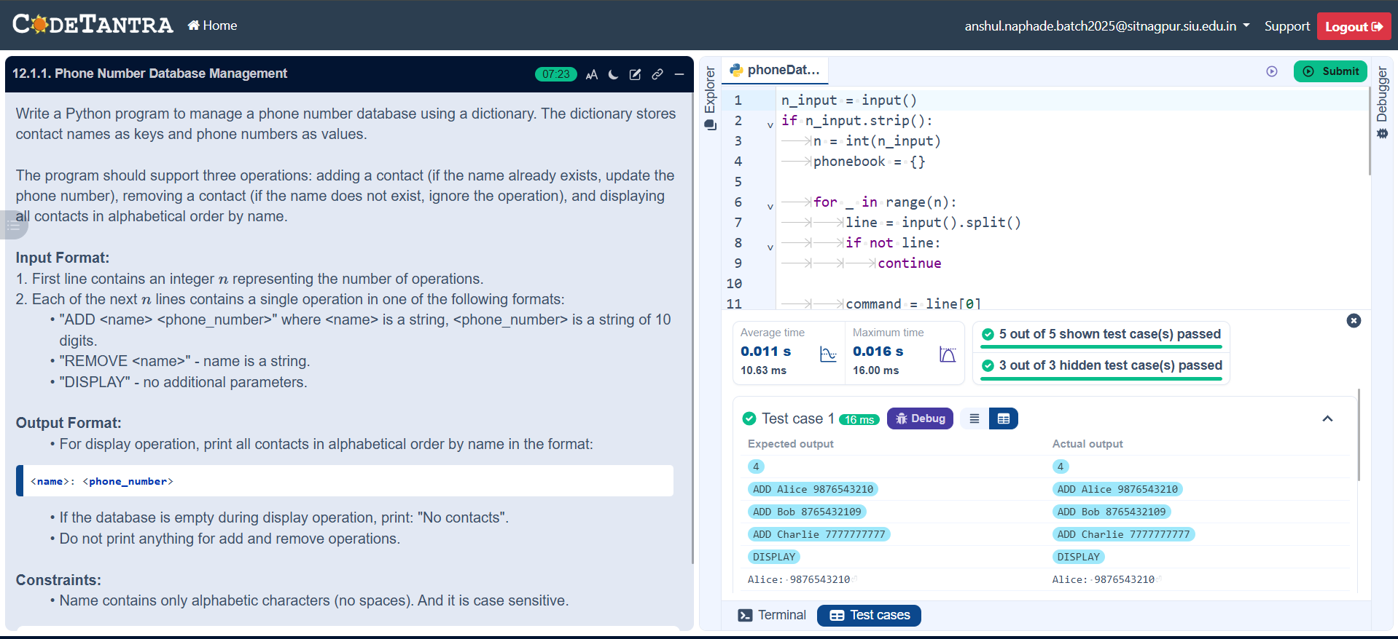

13.1.1

Problem Statement
Write a Python program using modular programming to generate the Fibonacci sequence up to a given maximum value.

Algorithm
Step 1: Start
Step 2: Input integer n
Step 3: If n ≤ 0
Print "Please enter a positive integer"
Stop
Step 4: Initialize:
a ← 0
b ← 1
seq ← empty list
Step 5: While a ≤ n do
Add a to seq
temp ← a + b
a ← b
b ← temp
Step 6: Print all elements of seq
Step 7: Stop

FLOWCHART:
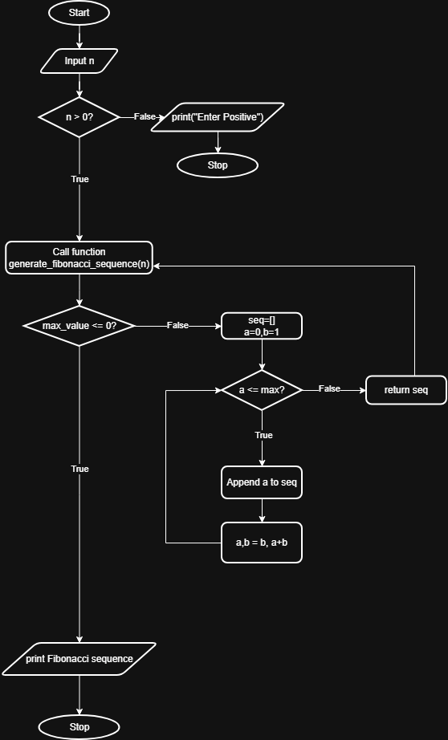

EXECUTION:
